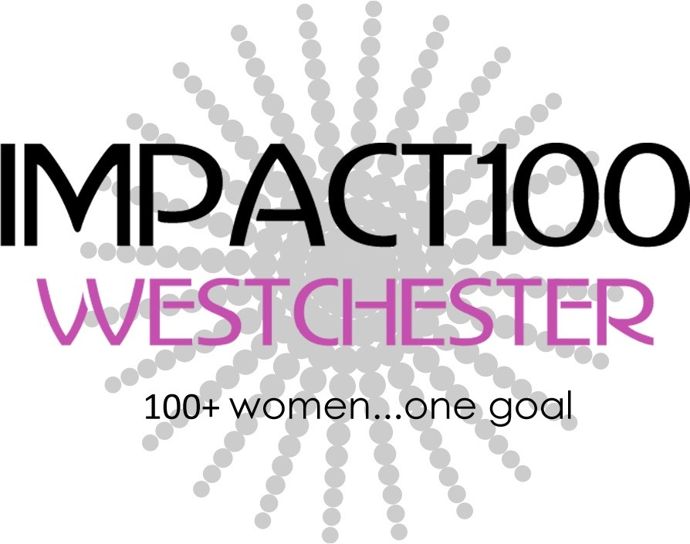
Membership Form

 New Member  Renewal Gifted Membership

Name______________________________________________________________________________

Email ___________________________________________ Phone____________________________

Address____________________________________________City_________________ZIP________

Membership Donation:
$1,100 (Grant Fund: $1000 + *Operating Fund: $100)
$______ Additional Contribution to the Operating Fund (Thank you!)

*Operating Fund covers essential costs- Annual meeting, Accounting review, Member Events, Printing and Supplies, PayPal, Technology, Insurance
Gift a membership $_________ to _________________________________________________
Gifted Member’s email:________________________Gifted Member’s phone:______________
Payment:
Check attached – Mail this form and check to:
Impact100 Westchester, PO Box 634, Hartsdale, NY 10530-0634

I’d like to donate Stock or Mutual Funds:
Please contact treasurer@impact100westchester.org

Additional Information:

___Please contact me about participating on a committee

___Please contact me about matching gifts

___Please contact me about hosting an information session

Your Interests and Skills___________________________________________________________

info@impact100westchester.org| www.impact100westchester.org
Impact100 Westchester engages women in philanthropy and collectively funds grants for charitable initiatives in the Westchester region.

